Achieving God’s Agenda Pastor Don Brock

Use this guide by yourself, with a friend, or in a group to help you pursue a deeper relationship with Jesus this week!

Open
In today’s passages (Nehemiah 6:1-29) Pastor Don looks at one of the great heroes of the Old Testament. He was not a prophet nor a religious leader. He was an ordinary guy who believed in God and prayer. And once he knew what God wanted him to do (after praying and fasting) God showed up big time. The impossible became possible.

Ask your group if anyone has had a time that things seemed impossible. Maybe they were at the end of their rope and lost hope. But then they prayed and trusted God… and God showed up.

BIG THOUGHT
Prayer really does change everything. If you want to find purpose and clarity in your life… you have to believe God and His purpose for you.

- Read Nehemiah 1 to get the “big picture” of what was going on.

- Discuss who Nehemiah was. Look him up in a Bible Encyclopedia.

- Read Nehemiah 6:5-7 and ask yourself about a time your biggest discouragement came from people who gossiped about you. Maybe they were even close friends.

- What did Nehemiah consistently do each time he ran into a potential roadblock?

- Any purpose given to us by God is compelling. Nothing comes close by comparison. What is God’s purpose for your life based on Scripture? It's the same purpose for all believers. This is our general purpose.

- What is your specific purpose from God? This is based on your spiritual giftedness, experiences, training and passion.

Take it Further
Thank the Lord for making you with a divine purpose. You are not an accident. You were not a mistake. Plan a spiritual retreat where you focus on God and his purpose for your life.
Daily Readings
Day 1: Matt. 5:11-12 Day 2: Gal. 6:9
Day 2: James 1:5 Day 5: Jeramiah 29:11
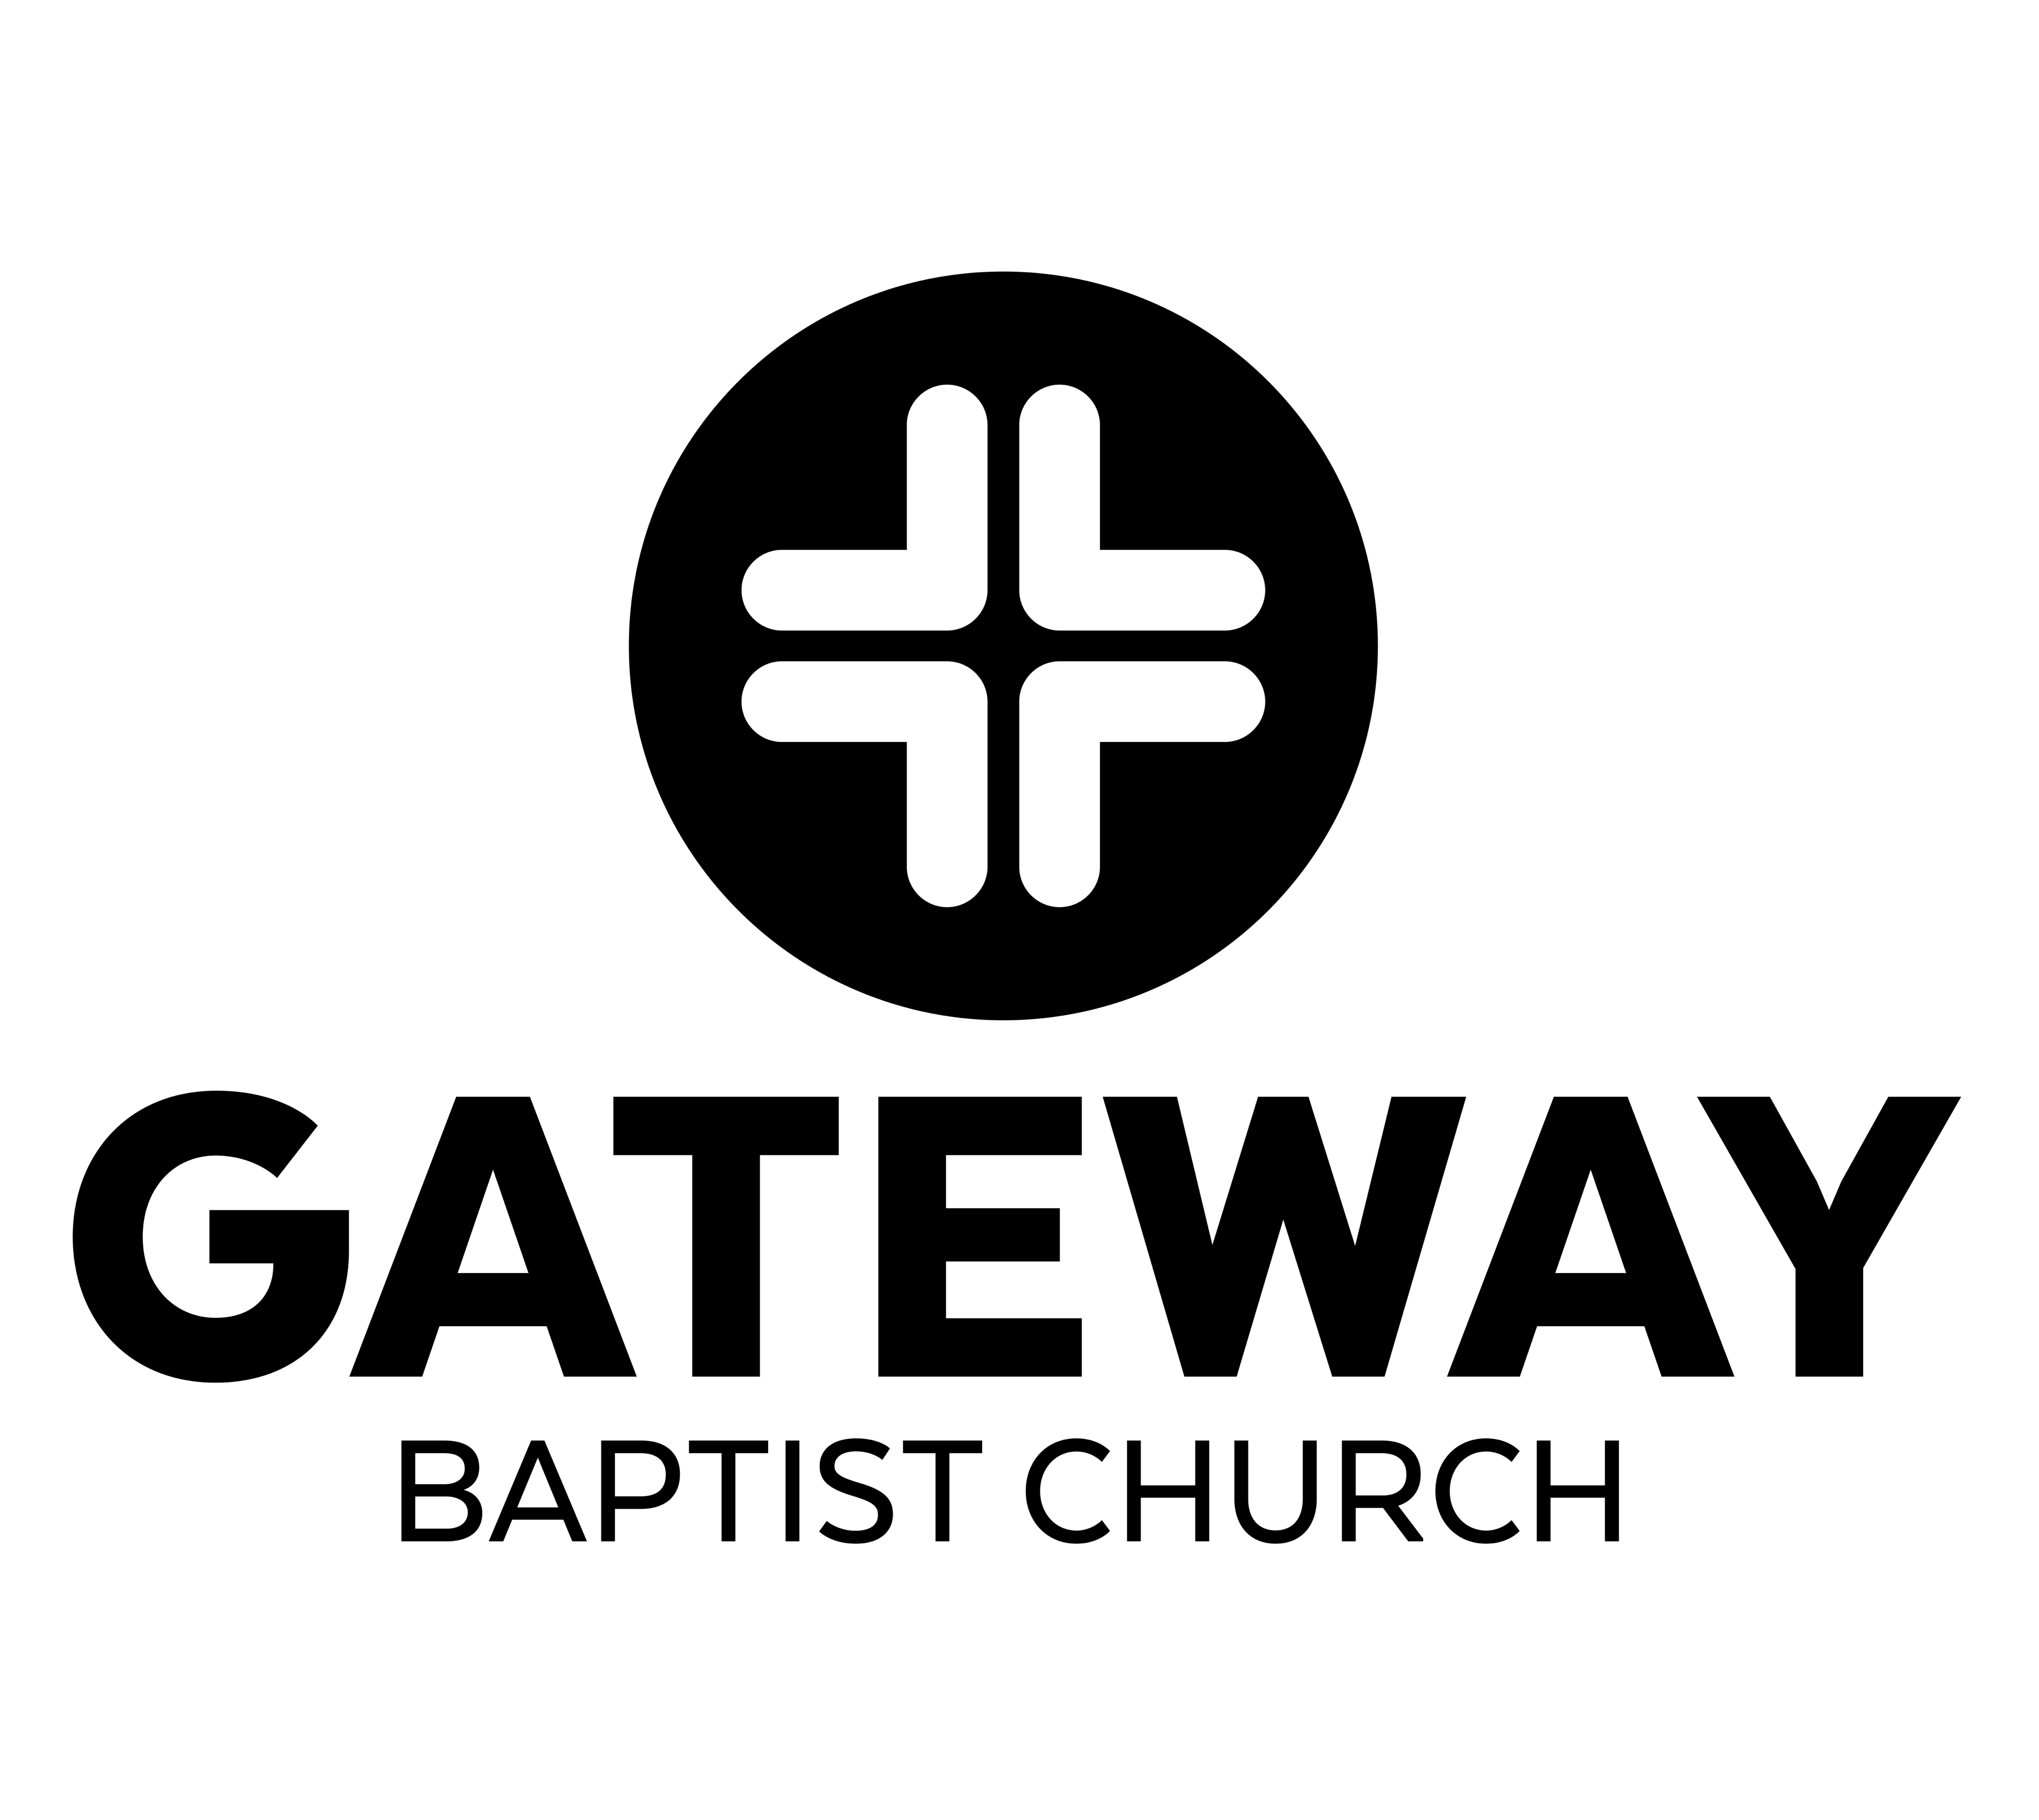
Day 3: Luke 18:1 Day 6: 2 Chron. 16:9
Memory Verses: Luke 10:27

1651 Dutch Fork Rd., Irmo, SC www.gatewaybc.com

